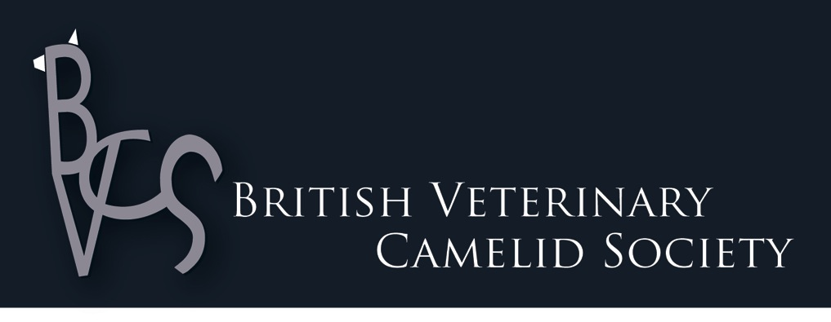

**CONFERENCE 2017**

**18th/19th November 2017**

**The Manor House Hotel & Golf Club, Castle Combe, Nr Bath**

Generously Supported by British Camelids Ltd

Also Supported by St Francis Group

Speakers

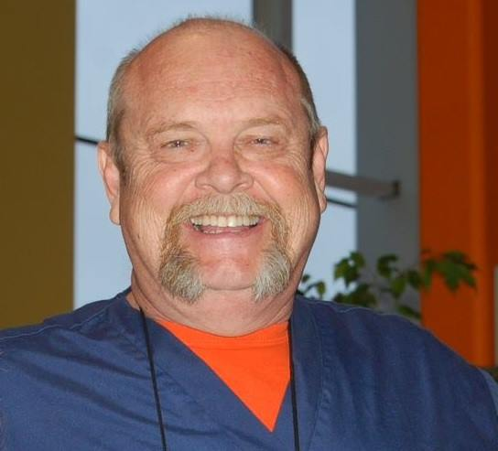David Pugh

David Gartrell Pugh arrived at the Auburn University CVM in July of 1990. He was an agriculture major at Austin Peay University in 1971 and 1972, transferring to the University of Georgia in 1973, where he earned a BSA (double major in Animal Science and Biological/Plant Sciences), a DVM, and an MS (Animal & Dairy Science – Ruminant Nutrition) degrees. He received post-DVM training at Virginia Tech (Equine Clinical Nutrition) and Texas A & M University (Theriogenology), and a MA in Agricultural Entomology (External Pararsites) from Auburn University. He is a Diplomate of the American College of Theriogenology (1986), the American College of Veterinary Nutrition (1992), and the American College of Veterinary Microbiology (Parasitology 2011).

Pugh was a large animal practitioner for five years in Georgia, held faculty positions at the University of Georgia (assistant professor) and Auburn University (professor, Large Animal Medicine), was a Technical Services Veterinarian for Fort Dodge Animal Health and Pfizer Animal Health, and was the Project Veterinarian and Director of Operations for the AU Equine Source Plasma Project and an Adjunct Professor of Pathobiology at Auburn University. In 2014, he was appointed Director of the Alabama State Veterinary Diagnostic Laboratory System.

Pugh has received five university and five national awards for teaching, and was the 2006 recipient of the AM Mills Award for contributions to Veterinary Medicine.

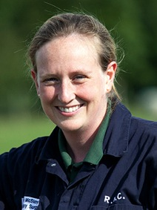Alex McSloy

Alex McSloy graduated from Cambridge University Vet School in 2003. She then undertook an internship followed by a residency in Large Animal Internal Medicine at the University of Wisconsin. On returning to the UK, she took up a temporary position at The Royal Veterinary College in the Equine Hospital followed by another position in the Farm Animal Hospital. She then completed a PhD before returning to run the Farm Animal Hospital at The Royal Veterinary College in 2012.

Alex is known among British Alpaca breeders for her involvement in the BAS Caring for Alpacas DVD and her regular articles in The Alpaca magazine.

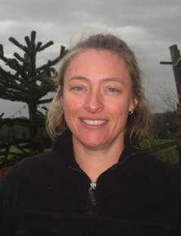Claire E Whitehead

Claire Whitehead [BVM&S MS DipACVIM(Large Animal) MRCVS] developed a passion for alpacas on the family farm. She completed a Residency in Large Animal Internal Medicine at The Ohio State University in July 2005, working under Dr David Anderson. Llamas and alpacas formed approximately 95% of her heavy caseload there. She stayed on at Ohio State for another year as a clinical instructor in Camelid Medicine and Reproduction, returning to the Royal Veterinary College in the UK in February 2007 where she established the first referral service catering specifically for Camelids alongside other farm animals in the UK. In May 2011, she set up in private practice running a camelid-only referral and consultancy practice and runs courses for vets and owners/breeders on Camelid Health and Reproduction. In the summer of 2015, Claire has opened a brand new purpose-built Referral Clinic for Camelids. Claire has co-written an owners’ manual on Neonatal Care for Camelids and guest-edited a special edition of the Veterinary Clinics of North America on Alpaca and Llama Health Management (2009). She is the current President of the British Veterinary Camelid Society.

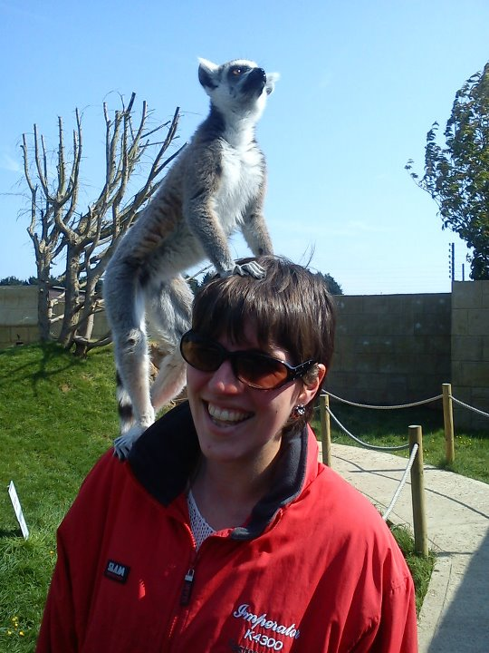

Jenny Grewel

I have had an interest in camelid veterinary work since vet school, and I have pursued that interest throughout my career. I graduated from Bristol in 2008, and stayed to do an 18 month farm animal internship. I worked as a farm animal vet in Wiltshire for another 6 years, continuing to do as much camelid work as possible, and last year I became the first vet to complete the Certificate in Camelid Practice. I am currently based in Wiltshire as a self-employed vet.

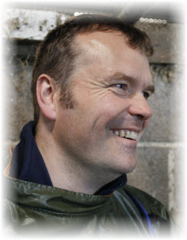Alastair Hayton

Alastair Hayton [BVM&S DCHP MRCVS] qualified at Edinburgh in 1993. After spending a period of time working in Cirencester he joined Kingfisher Veterinary Practice. In 1997 he attained a Certificate in Cattle Health and Production, and in 2003 the RCVS Diploma of Cattle Health and Production.

Since 2009 he has been an appointed examiner for the Royal College of Veterinary Surgeons Diploma in Cattle Health and Production and received RCVS Specialist status in Cattle Health and Production in 2011. He is a member of the Nottingham University Dairy Herd Health Group.

His areas of interest include all aspects of cattle medicine and husbandry, in particular nutrition, mastitis and organic production. Outside his practice work he has performed a large amount of consultancy to both farm and allied industry and is an associate consultant of Evidence Based Veterinary Consultancy. Between 2002 and 2005 he sat on BCVA council and between 2003 and 2005 chaired Bovine TB and welfare for BCVA. In 2006 he was jointly awarded the Vetoquinol award for "Outstanding contribution to the Cattle Veterinary Industry". ” Alastair has authored a number of papers in the field of cattle health and is Co-author with Kat Bazely, also of Synergy, of “Practical Cattle Farming” published by Crowood Press.

Provisional Programme 2017 (Timings subject to change)

Saturday 18th November

0830-0900 Arrival & registration

0900-0950 Internal Parasites – Diagnosis, treatment and management David Pugh

0950-1040 Internal Parasite problems continued David Pugh

**Coffee Break**

1110-1200 Vaccinations and immunity – facts and conjecture Alex McSloy

1200-1250 External Parasites – Diagnosis, treatment and management David Pugh

**Lunch**

1400-1450 Topics from the Oregon International Camelid Martijn ‘t Hoen and Health Conference 2017 Claire Lomas

1450-1540 Camelid neonatal care in private practice Claire Whitehead

**Tea Break**

1610-1700 Nutrition and its influence on parasites David Pugh

**Evening** **CONFERENCE DINNER AT THE HOTEL**

Sunday 19th November

0900-1030 BVCS AGM

**Coffee Break**

1100-1200 Metabolic disease problems in Camelid herds – a Alex McSloy

case-based discussion

1200-1250 Nutrition and production in camelids David Pugh

**Lunch**

1400-1450 Clinical Case Discussions Jenny Grewel

1450-1540 A review of the performance of the Enferplex bTB test in

Camelids and other species Alastair Hayton

1600-1630 Tea Break and Close

Conference Information

Venue

**The Manor House Hotel & Golf Club, Castle Combe, Nr Bath, Wiltshire, SN14 7HX**

Surrounded by 365 acres of spectacular Cotswolds countryside, The Manor House is one of the most beautiful destinations you will discover. At the heart of the 14th century village of Castle Combe, and waiting to be explored are the carefully tended parkland, woodland and gardens and village beyond. The hotel has an award-winning restaurant so consider staying over and enjoying the facilities.

Getting to the venue:

* By car: Easy access via the M4, between J17 and J18.
* By public transport: train to Chippenham, very easy from London Paddington or the west country. Taxi ride to hotel is 15-20 mins.
* By air: closest airport is Bristol, or fly to London Airports, get to Paddington Station and take a train to Chippenham (this is a direct fast train taking approx. 70 mins): then taxi to the hotel.

Professional Development

Certificates of attendance will be provided as evidence of participation in the event for the purpose of Continuing Professional Development.

Social Events

For those arriving on Friday evening, we will start gathering in the bar for drinks (and food…) from 7pm if you care to join the group!

On Saturday evening, we will be celebrating our annual conference as usual with a dinner in the hotel restaurant. This is included in the “whole weekend” conference package! If you are just coming to a single day of the conference but want to come to the dinner, please add this in the appropriate column on the booking form. Note that this is an exceptional restaurant and we have managed to secure a really good price for this dinner in a private dining room. Numbers are limited in this room to 30, so please book early to avoid disappointment. Always a fun evening!

Throughout the weekend there will be ample opportunity for socialising and networking during refreshment breaks.

Accommodation

A number of rooms have been reserved for the conference weekend and must be booked separately, direct with the hotel (01249 784808). In order to get the reduced rate of £120 +VAT per night (B&B), quote BVCS and the date of the conference. Those applying late may have to arrange their own accommodation elsewhere! **Rooms are only reserved for us until 15th September and will then be released to the general public and availability cannot be guaranteed**. Again, this is a very good price for these rooms – they normally sell them for over £300 per night!

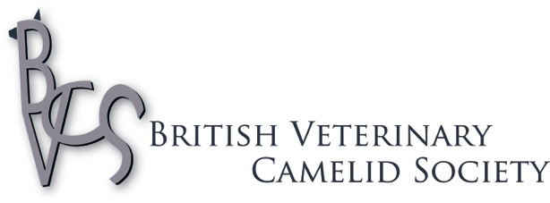Conference

18th/19th November 2017

**The Manor House Hotel & Golf Club, Castle Combe, Nr Bath, Wiltshire, SN14 7HX**

**DELEGATE REGISTRATION FORM**

**DELEGATE DETAILS**

|  |
| --- |
|  |

Title/Name:

Add accompanying partner’s name:

|  |
| --- |
|  |

Practice:

|  |
| --- |
|  |

Address:

|  |
| --- |
|  |

Telephone :

E mail:

|  |
| --- |
|  |

Likely arrival time:

Special requests: (eg.dietary)

Conference Costs & Application Form

Participation is limited to members of the BVCS. If you have not applied/paid via the website during the last year, please do so now via the [BVCS website](http://s1.itseeze.co.uk/sites/vets/join-the-bvcs/), then tick the box on the application form. Annual membership costs only £30 and includes access to the discussion forum as well as the members’ area of the website.

|  |  |  |  |  |  |
| --- | --- | --- | --- | --- | --- |
| **Package** | **Details** | **\*Cost until 13/10/17** | **\*Cost**  **after 13/10/17** | **Student Rate (+ unemployed 2017 grads)** | **Amount to pay (£)** |
| **Whole weekend Conference**  Saturday + Sunday conference, lunches and refreshments; and conference dinner on Saturday | Book Accommodation separately | £235 | £270 | £200  (£230 after 13/10/17) |  |
| **Single day Conference**  **I**ncludes conference on one day only, refreshment breaks and lunch | Saturday or Sunday conference (SPECIFY) | £110 | £140 | £80  (£100 after 13/10/17) |  |
| **Both Days (No dinner)**  **I**ncludes conference with lunch and refreshments | Conference dinner not included | £180 | £210 | £160  (£180 after 13/10/17) |  |
| **Add dinner (for delegate or non-delegate partner)** |  | £60 | £60 | £60 |  |
| **Extra copies of Proceedings** | In print: order early to ensure availability | £15 (TBC) |  |  |  |
| **BVCS Membership** (for those not already members) | Visit [BVCS website](http://s1.itseeze.co.uk/sites/vets/join-the-bvcs/) for details |  |  | Free | Tick |
|  |  |  |  | **Total payable** |  |

**\*Please note! There are 2 different rates depending on booking date!** Any bookings received after 13/10/17 will be subject to a late booking supplement. This is because late bookings cause a lot of extra work! So please book early and save us some time – and yourself some money.

Payment

Send completed registration form and payment to:

Secretary, BVCS, Foxes Grove, Punnetts Town, Heathfield, E. Sussex TN21 9PE or [**secretary@camelidvets.org**](mailto:secretary@camelidvets.org)

Make cheques payable to British Veterinary Camelid Society

OR pay by bank transfer (note your name as ref): Lloyds TSB, Account No (0)3316695, Sort code 30-95-01

For those outside the UK, please remember that you will need to pay for all bank transfer fees so that

the full amount is credited to the BVCS account. BIC LOYDGB21103, IBAN GB79

LOYD 3095 0103 3166 95

**For bank transfers, please confirm date of payment and the reference used in order to**

**facilitate tracking of payments.** Receipts will be issued at the conference unless requested earlier.